JUnit Testing Exercises

# Exercise 1: Setting Up JUnit

Scenario:

You need to set up JUnit in your Java project to start writing unit tests. Steps:

1. Create a new Java project in your IDE (e.g., IntelliJ IDEA, Eclipse).
2. Add JUnit dependency to your project. If you are using Maven, add the following to your pom.xml:

<dependency>

<groupId>junit</groupId>

<artifactId>junit</artifactId>

<version>4.13.2</version>

<scope>test</scope>

</dependency>

1. Create a new test class in your project.

**Solution:**

**Calculato.java**

package com.example;

public class Calculator {

public int add(int a, int b) {

return a + b;

}

}

**CalculatorTest.java**

package com.example;

import static org.junit.Assert.*;

import org.junit.Test;

public class CalculatorTest {

*@Test*

public void testAdd() {

Calculator calc = new Calculator();

int result = calc.add(2, 3);

*assertEquals*(5, result);

}

}

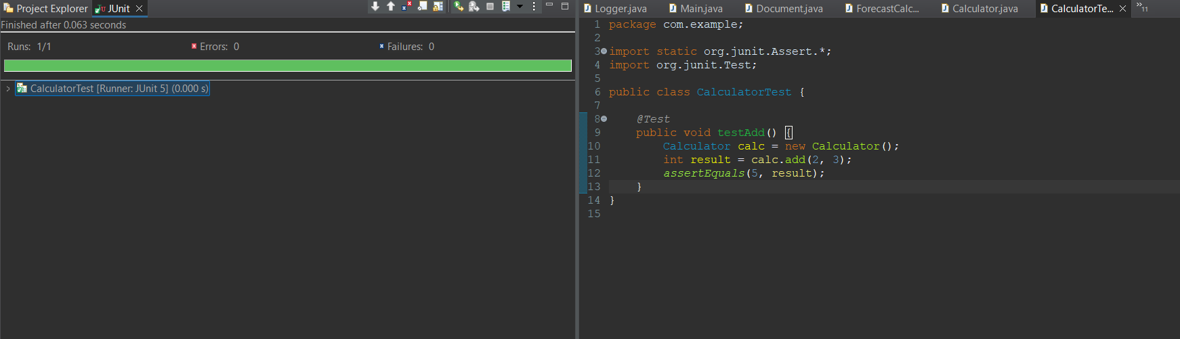

# Exercise 3: Assertions in JUnit

Scenario:

You need to use different assertions in JUnit to validate your test results. Steps:

1. Write tests using various JUnit assertions.

**Solution Code:**

public class AssertionsTest { @Test

public void testAssertions() {

// Assert equals assertEquals(5, 2 + 3);

// Assert true assertTrue(5 > 3);

// Assert false assertFalse(5 < 3);

// Assert null assertNull(null);

// Assert not null assertNotNull(new Object());

}

}

Solution:

package com.example;

import org.junit.Test;

import static org.junit.Assert.*;

public class AssertionsTest {

*@Test*

public void testAssertions() {

// Print statement (optional)

System.***out***.println("Running JUnit assertions...");

// Assert equals

*assertEquals*(5, 2 + 3);

// Assert true

*assertTrue*(5 > 3);

// Assert false

*assertFalse*(5 < 3);

// Assert null

*assertNull*(null);

// Assert not null

*assertNotNull*(new Object());

}

}

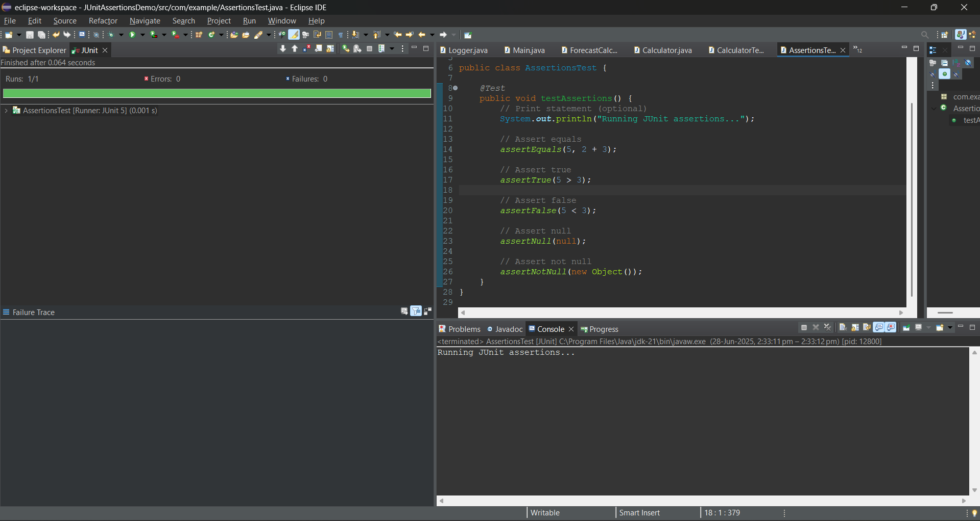

# Exercise 4: Arrange-Act-Assert (AAA) Pattern, Test Fixtures, Setup and Teardown Methods in JUnit

Scenario:

You need to organize your tests using the Arrange-Act-Assert (AAA) pattern and use setup and teardown methods.

Steps:

1. Write tests using the AAA pattern.
2. Use @Before and @After annotations for setup and teardown methods.

**Solution:**

**CalculatorTest.java**

package com.example;

import org.junit.After;

import org.junit.Before;

import org.junit.Test;

import static org.junit.Assert.*;

public class CalculatorTest {

private Calculator calculator;

*@Before*

public void setUp() {

System.***out***.println("🔧 Setup before each test");

calculator = new Calculator(); // Arrange

}

*@After*

public void tearDown() {

System.***out***.println("🧹 Cleanup after each test");

}

*@Test*

public void testAddition() {

// Act

int result = calculator.add(3, 4);

// Assert

*assertEquals*("Addition failed", 7, result);

}

*@Test*

public void testMultiplication() {

// Act

int result = calculator.multiply(2, 5);

// Assert

*assertEquals*("Multiplication failed", 10, result);

}

}

